Ansible Task-04

Task Title
Create and Use Ansible Vault in a Playbook
Objective
To securely store sensitive credentials using Ansible Vault and use those encrypted variables inside an Ansible playbook.
Prerequisites
- Ansible installed
- Inventory configured (/etc/ansible/hosts)
- Target hosts reachable
- Basic YAML knowledge
Step-by-Step Implementation:
Step 1: Create a variables file
Create a YAML file to store sensitive data.
vi pass.yml
Add the following content:
user: admin
password: admin@123
Step 2: Encrypt the variables file using Ansible Vault
Secure the file by encrypting it.
ansible-vault encrypt pass.yml
Enter and confirm the vault password.
File pass.yml is now encrypted.
Step 3: Create a playbook to use the vault file
Create a playbook that includes the encrypted variables file.
vi enter_vault.yml
Playbook content:
---
- name: Use Ansible Vault
hosts: all
become: yes

vars_files:
- pass.yml

tasks:
- name: Example task using vault variables
debug:
msg: "User is {{ user }} and Password is {{ password }}"
Step 4: Execute the playbook
Run the playbook by providing the vault password.
ansible-playbook enter_vault.yml --ask-vault-pass
Validation Steps
- Playbook executes without errors
- Vault password prompt appears
- Variables from the encrypted file are successfully accessed
- Task output confirms correct values
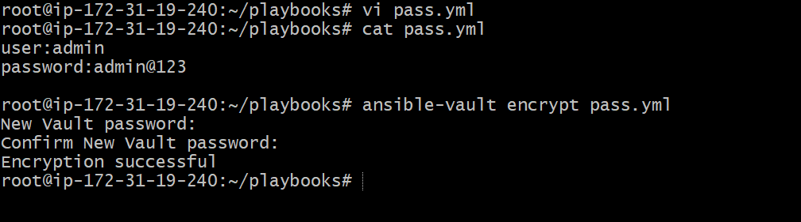
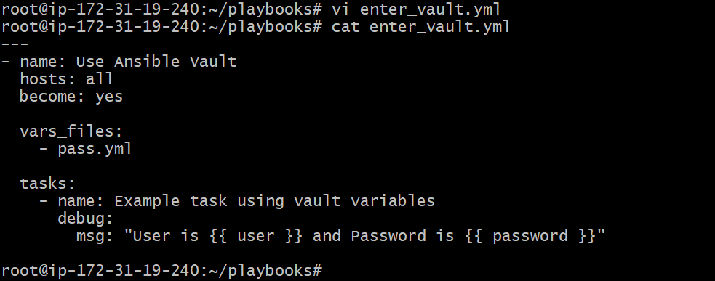
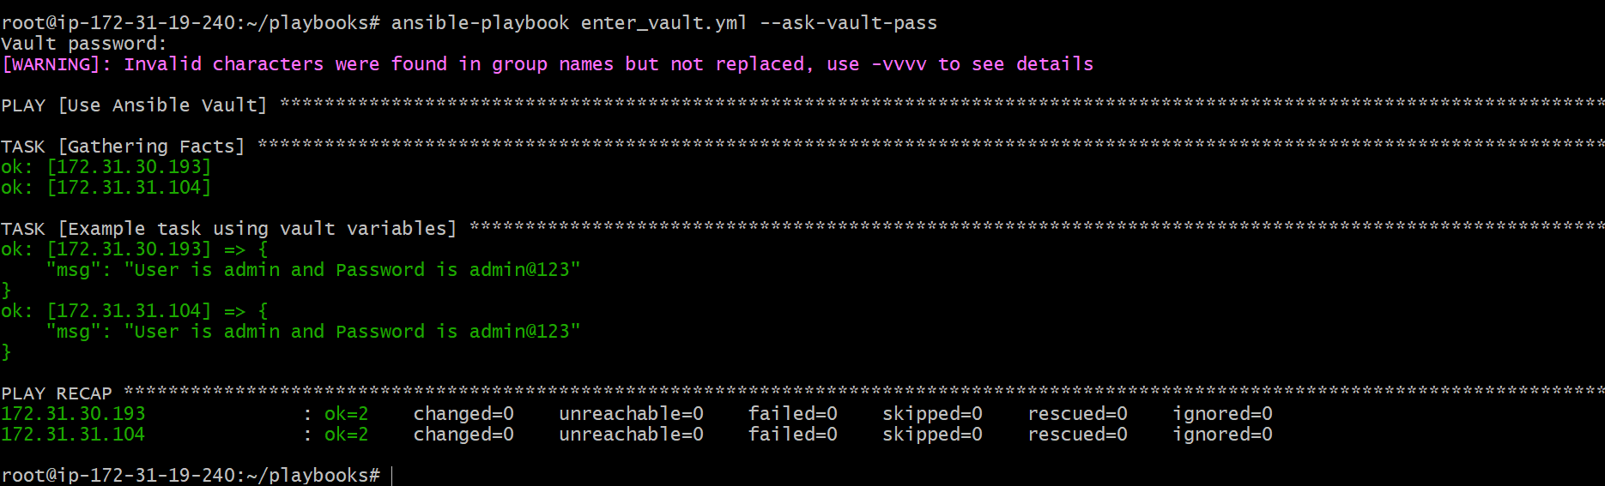

Issues Faced
- Variable name mismatch can cause undefined variable errors
- Incorrect YAML formatting (missing space after :) can break vault parsing
- Printing passwords using debug is unsafe in real environments
Conclusion
Ansible Vault was successfully used to encrypt sensitive variables and securely consume them in an Ansible playbook. Vault ensures that secrets remain protected while allowing automation tasks to run normally during execution.

Task Title
Install Apache on Ubuntu and RHEL-based Linux using Ansible when condition
Objective
To install and start the Apache web server on Ubuntu and RHEL/CentOS/Amazon Linux machines using a single Ansible playbook with OS-based when conditions.
Prerequisites
- Ansible installed on control node
- Inventory configured with Ubuntu and Linux hosts
- SSH connectivity to target machines
- Root or sudo access on target nodes
Step-by-Step Implementation:
Step 1: Create the Ansible playbook
Created a playbook file to handle Apache installation for multiple OS types.
vi Apache_ubuntu.yml
Step 2: Define OS-specific installation tasks
Added tasks using when condition to identify OS family and install the correct Apache package.
---
- name: Install Apache on Ubuntu and Linux
hosts: all
become: yes

tasks:
- name: Install Apache on Ubuntu
apt:
name: apache2
state: present
update_cache: yes
when: ansible_os_family == "Debian"
- name: Install Apache on RHEL/CentOS/Amazon Linux
yum:
name: httpd
state: present
when: ansible_os_family == "RedHat"
Step 3: Start and enable Apache service
Configured Apache service to start automatically based on OS.
- name: Start and enable Apache on Ubuntu
service:
name: apache2
state: started
enabled: yes
when: ansible_os_family == "Debian"
- name: Start and enable Apache on RHEL/CentOS/Amazon Linux
service:
name: httpd
state: started
enabled: yes
when: ansible_os_family == "RedHat"
Step 4: Execute the playbook
Ran the playbook on all hosts.
ansible-playbook Apache_ubuntu.yml

Validation Steps
- Apache installed on Ubuntu systems using apt
- Apache installed on RHEL-based systems using yum
- Apache service started and enabled on applicable systems
- Tasks skipped automatically on non-matching OS
- Play recap shows successful execution with skipped tasks as expected
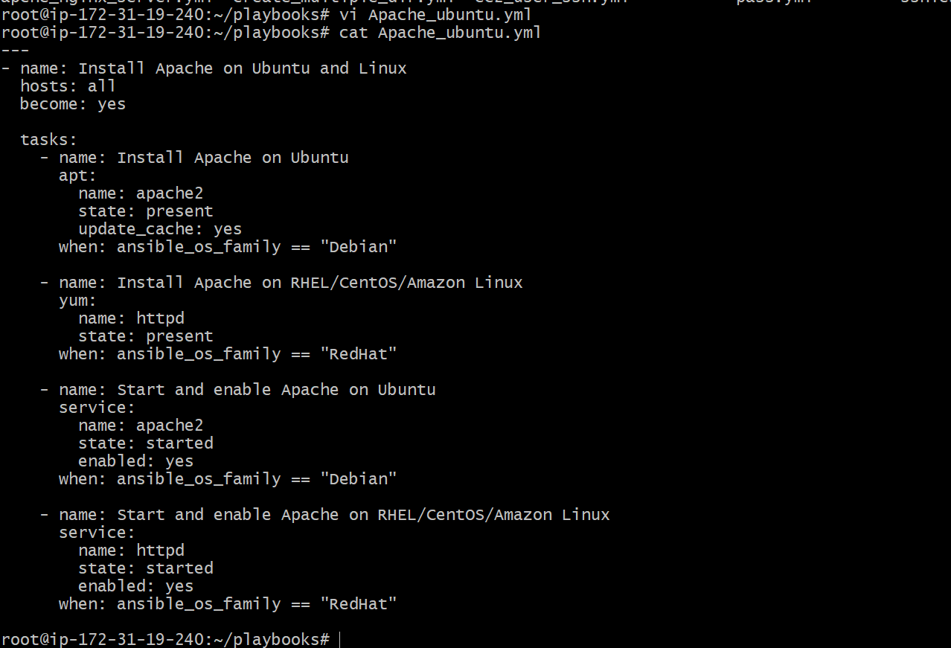
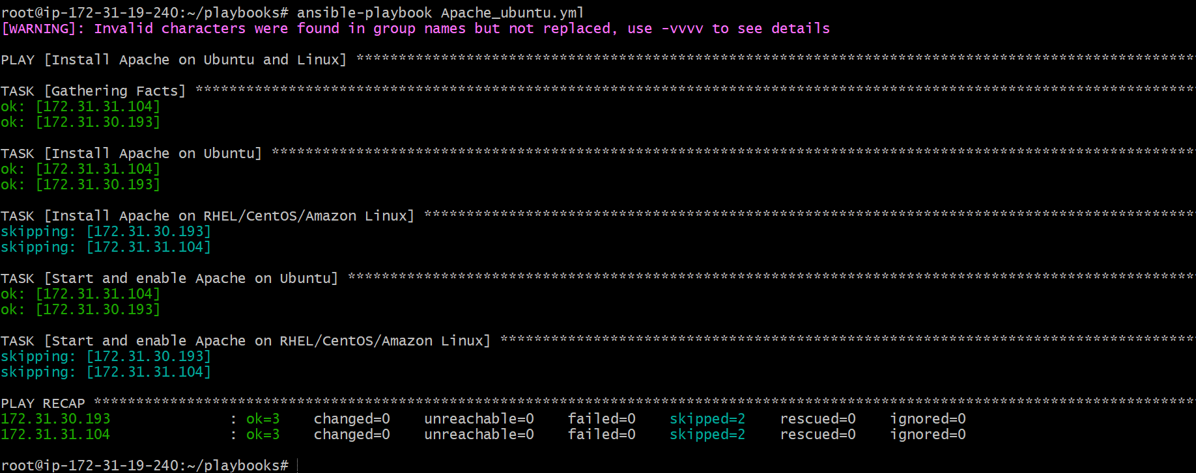
Issues Faced
- Warning about invalid characters in group names due to inventory naming
- Skipped tasks observed on systems where OS condition did not match (expected behavior)
Conclusion:
Apache was successfully installed and started on both Ubuntu and RHEL-based Linux systems using a single Ansible playbook. The when condition ensured that the correct package manager and service name were applied based on the operating system.

Task Title
Create ansible playbook using roles to configure LAMP stack
Objective
To configure a complete LAMP stack (Apache, MySQL, PHP) on Linux machines using Ansible roles for modular and reusable automation.
Prerequisites
- Ansible installed on control node
- Inventory configured with target hosts
- SSH connectivity and sudo access on target machines
- Ubuntu/Debian-based target servers
Step-by-Step Implementation:
Step 1: Create LAMP project directory
Created a project directory inside the playbooks directory.
mkdir lamp
cd lamp
Step 2: Create main playbook
Created the main playbook to call roles.
vi roll.yml
---
- name: Configure LAMP stack using roles
hosts: all
become: yes
roles:
- apache
- mysql
- php
Step 3: Create roles directory structure
Created role directories for Apache, MySQL, and PHP.
mkdir -p roles/apache/tasks
mkdir -p roles/mysql/tasks
mkdir -p roles/php/tasks
Step 4: Create Apache role
Defined Apache installation and service management tasks.
vi roles/apache/tasks/main.yml
---
- name: Install Apache
apt:
name: apache2
state: present
update_cache: yes
- name: Start and enable Apache
service:
name: apache2
state: started
enabled: yes
Step 5: Create MySQL role
Defined MySQL installation and service management tasks.
vi roles/mysql/tasks/main.yml
---
- name: Install MySQL
apt:
name: mysql-server
state: present
update_cache: yes

- name: Start and enable MySQL
service:
name: mysql
state: started
enabled: yes
Step 6: Create PHP role
Defined PHP installation and Apache restart tasks.
vi roles/php/tasks/main.yml
---
- name: Install PHP
apt:
name:
- php
- php-mysql
- libapache2-mod-php
state: present
- name: Restart Apache
service:
name: apache2
state: restarted
Step 7: Execute the playbook
Ran the playbook to configure the LAMP stack.
ansible-playbook roll.yml
Validation Steps
- Apache service is active and running
- MySQL service is active and running
- PHP packages installed successfully
- Play recap shows successful execution on all hosts
Verification commands:
systemctl status apache2
systemctl status mysql
php -v

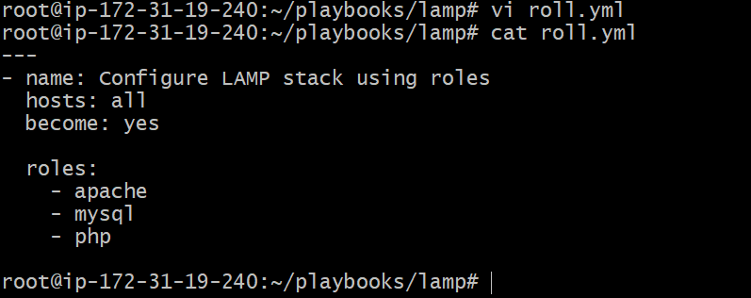
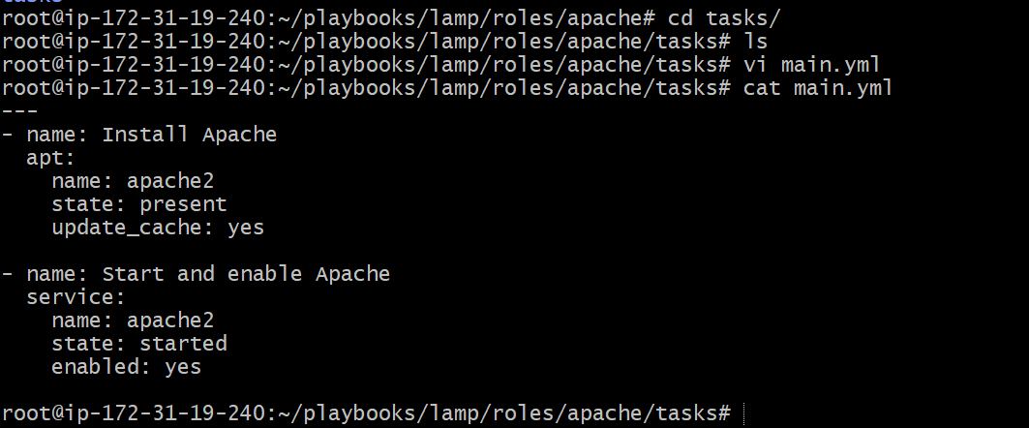
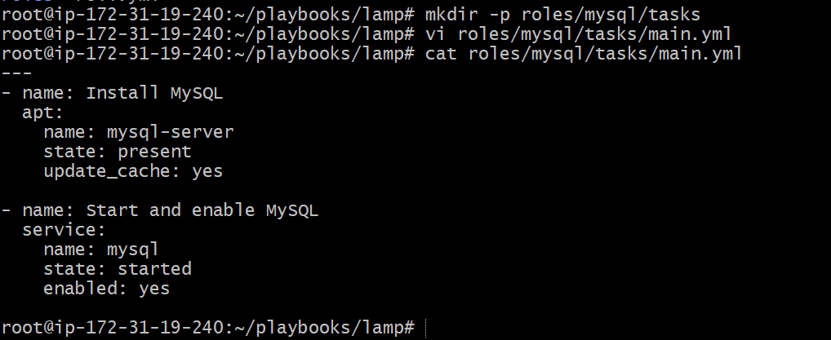
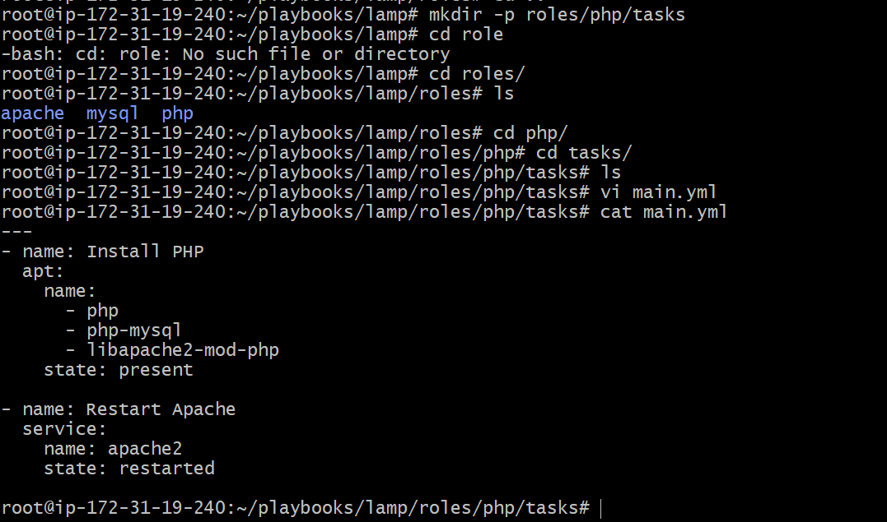
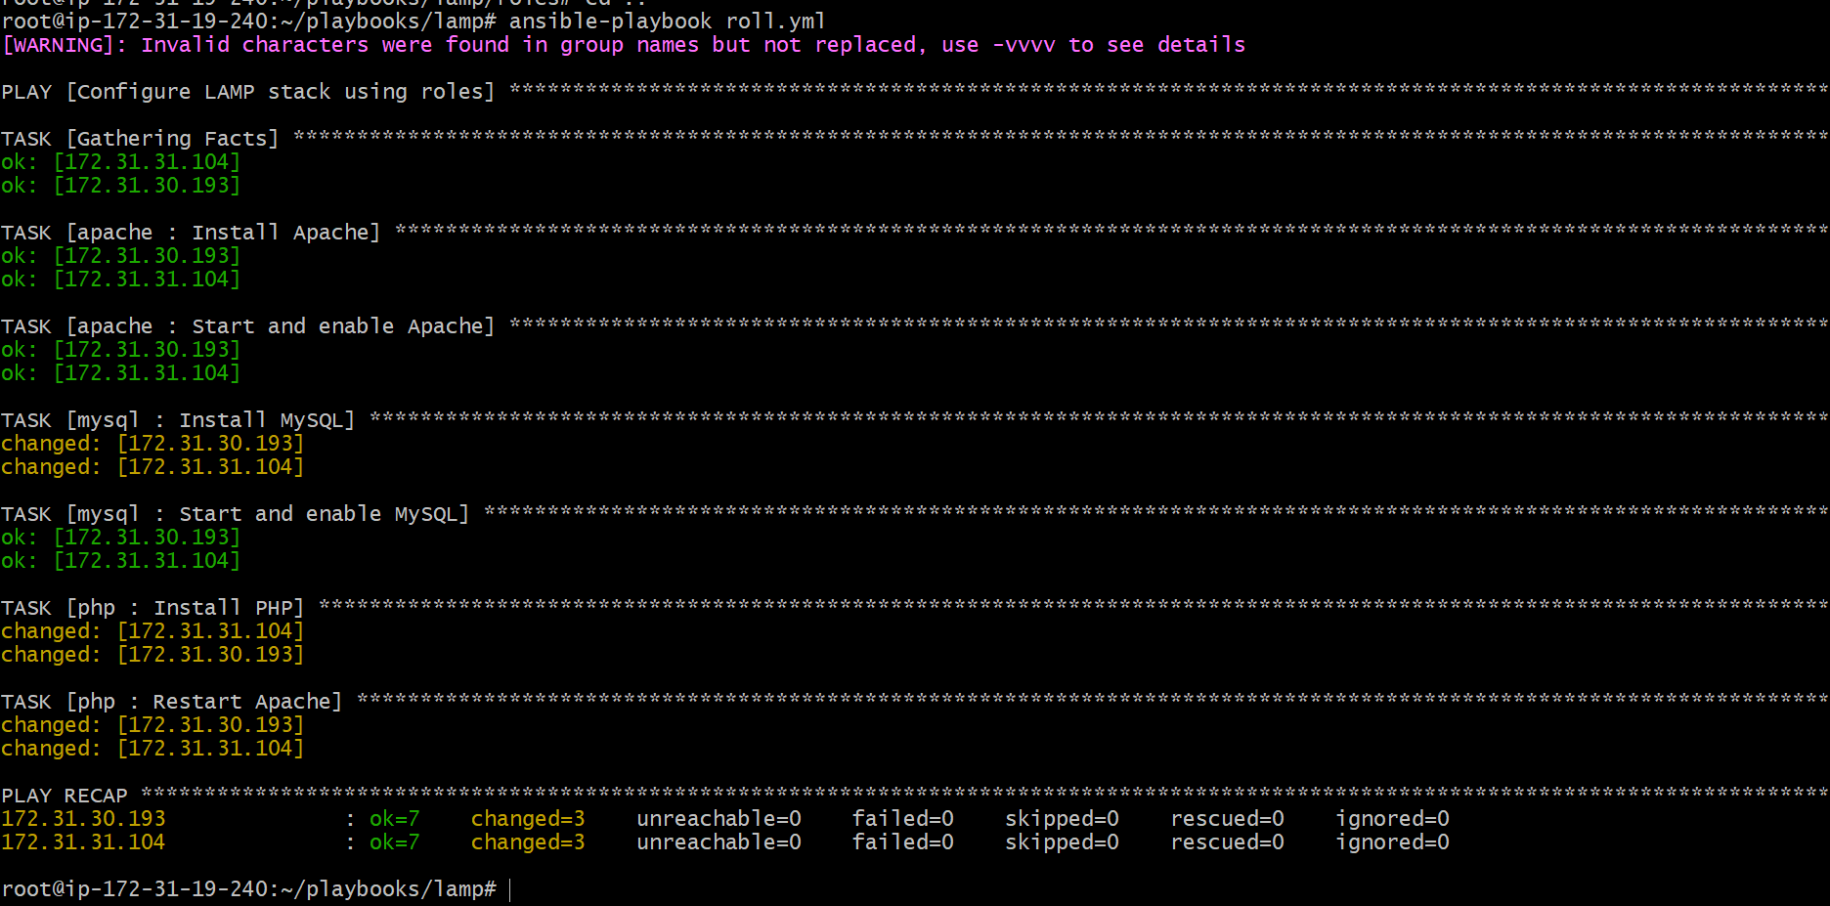
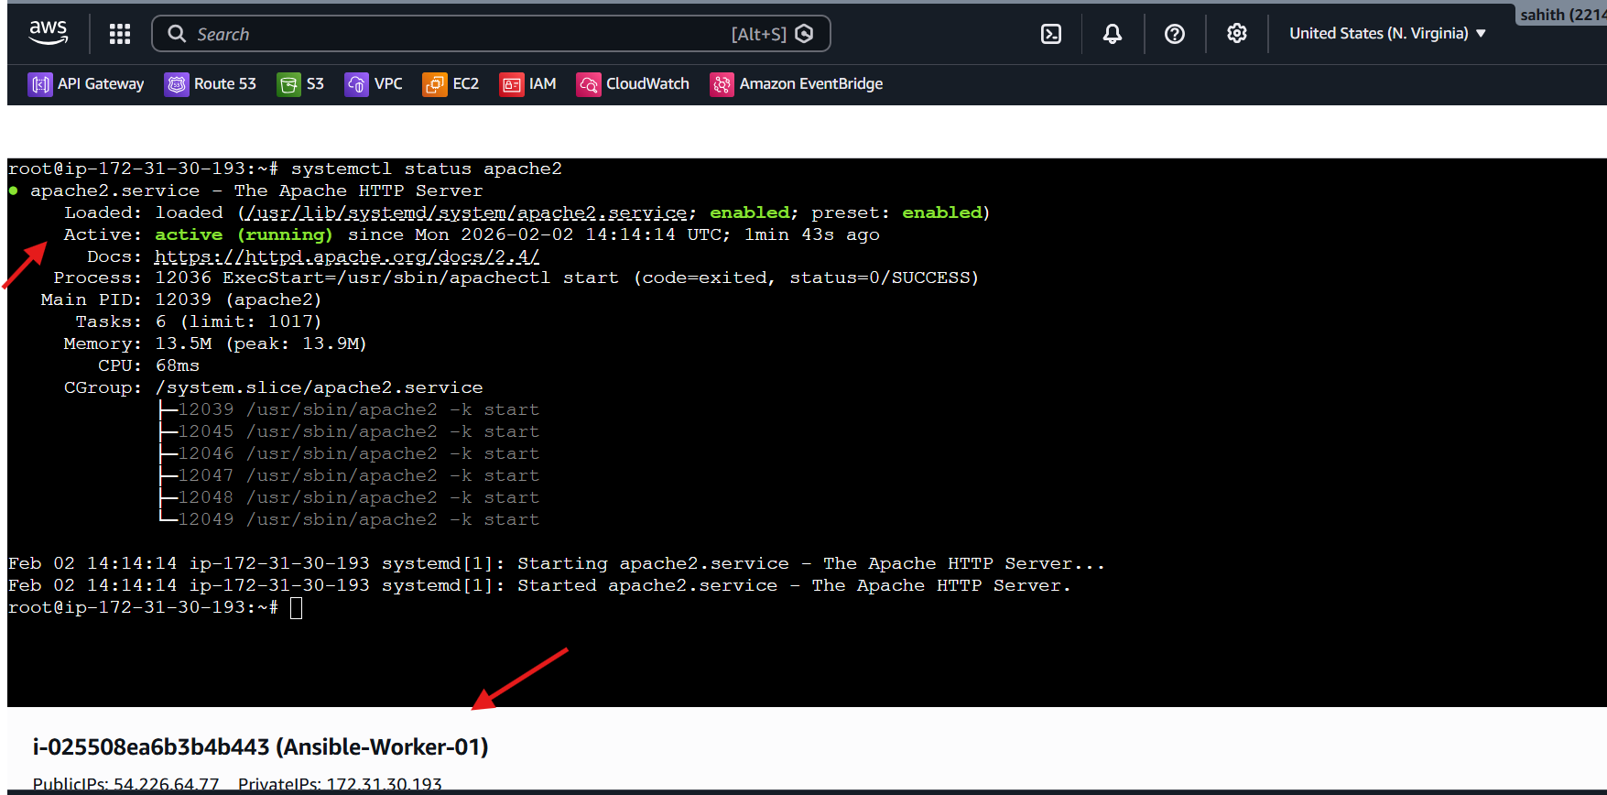
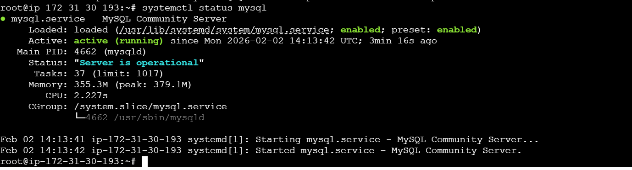
Issues Faced:
- Warning about invalid characters in inventory group names
- No functional errors during execution
Conclusion:
The LAMP stack was successfully configured using Ansible roles. Each component was managed independently through roles, improving modularity, reusability, and maintainability of the automation.

Task Title
Setup and Configure Ansible AWX on Ubuntu and Execute Playbooks via Web UI
Objective
To install Ansible AWX on an Ubuntu EC2 instance using Docker and the Ansible installer, access the AWX Web UI, configure projects and job templates, and successfully execute an Ansible playbook through AWX.
Prerequisites
- Ubuntu EC2 instance running
- Internet access
- Root or sudo privileges
- Ports 80/8052 allowed in security group
- Docker, Docker Compose, Git, and Ansible installed

Step-by-Step Implementation:
Step 1: Provision and access Ubuntu EC2 instance
- Launched EC2 instance for AWX
- Connected to the instance using SSH
Step 2: Update system and install required packages
apt update -y
apt install -y docker.io docker-compose git ansible
Enabled and verified Docker:
systemctl enable docker
systemctl start docker
systemctl status docker
Verified versions:
docker --version
docker-compose --version
ansible --version
Step 3: Clone Ansible AWX repository
git clone -b 17.1.0 https://github.com/ansible/awx.git
cd awx
Step 4: Configure AWX installer
Moved to installer directory and edited inventory:
cd installer
vi inventory
Configured:
- admin_user
- admin_password
- pg_password
- Docker-related paths
Step 5: Install AWX
Executed AWX installation playbook:
ansible-playbook -i inventory install.yml
Installer performed:
- Docker container creation
- Database migrations
- Service initialization
- Preload data creation
Step 6: Verify AWX containers
docker ps
Confirmed containers:
- awx_web
- awx_task
- awx_postgres
- redis
Step 7: Access AWX Web UI
- Opened browser and accessed:
http://<public-ip>
- AWX login page displayed
- Logged in using admin credentials
- Dashboard loaded successfully
Step 8: Create AWX Project
- Navigated to Resources → Projects
- Created a project with:
  - Source Control Type: Git
  - Repository URL: https://github.com/ansible/awx.git
  - Organization: Default
- Project synced successfully
Step 9: Create Job Template
- Navigated to Resources → Templates
- Created a Job Template with:
  - Inventory: Demo Inventory
  - Project: awx
  - Playbook: selected from project
  - Credentials: SSH Demo Credential
- Saved the template
Step 10: Execute Job Template
- Launched the job template
- Monitored execution under Jobs → Output
- Playbook executed successfully with no failures
Validation Steps
- AWX Web UI accessible
- Docker containers running
- Project synced successfully
- Job template created
- Playbook execution completed successfully
- Job output showed ok status
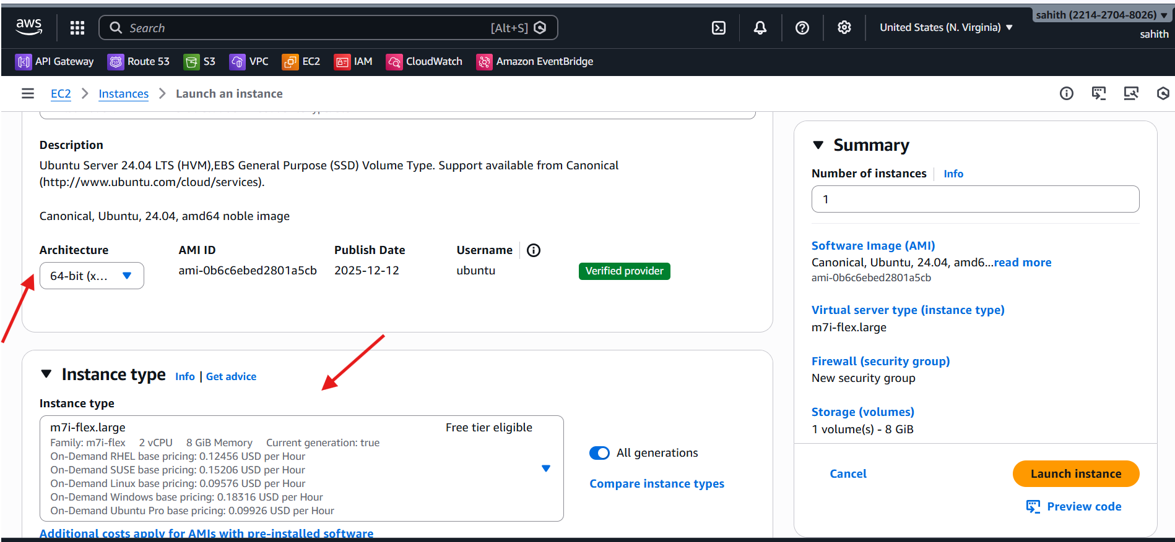
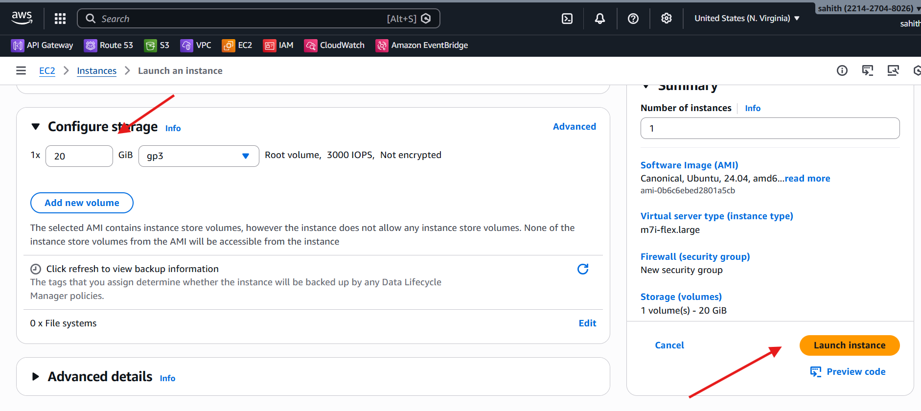
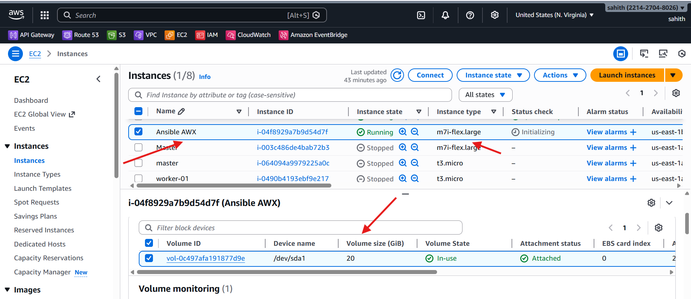
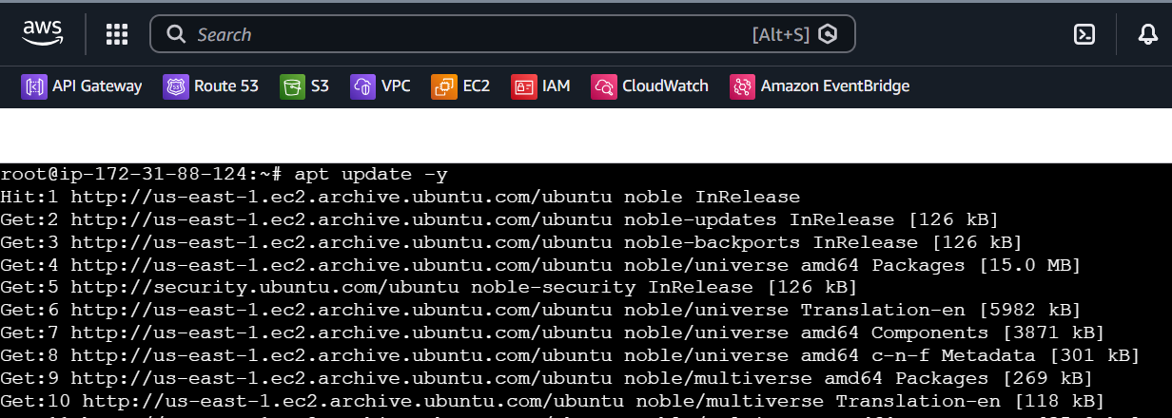
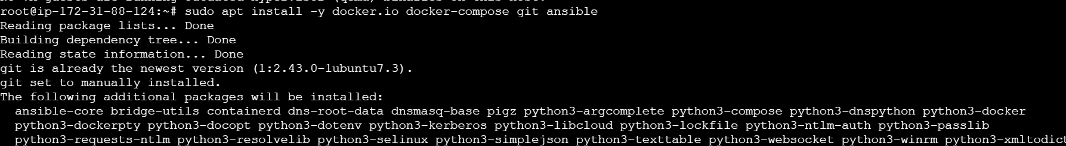
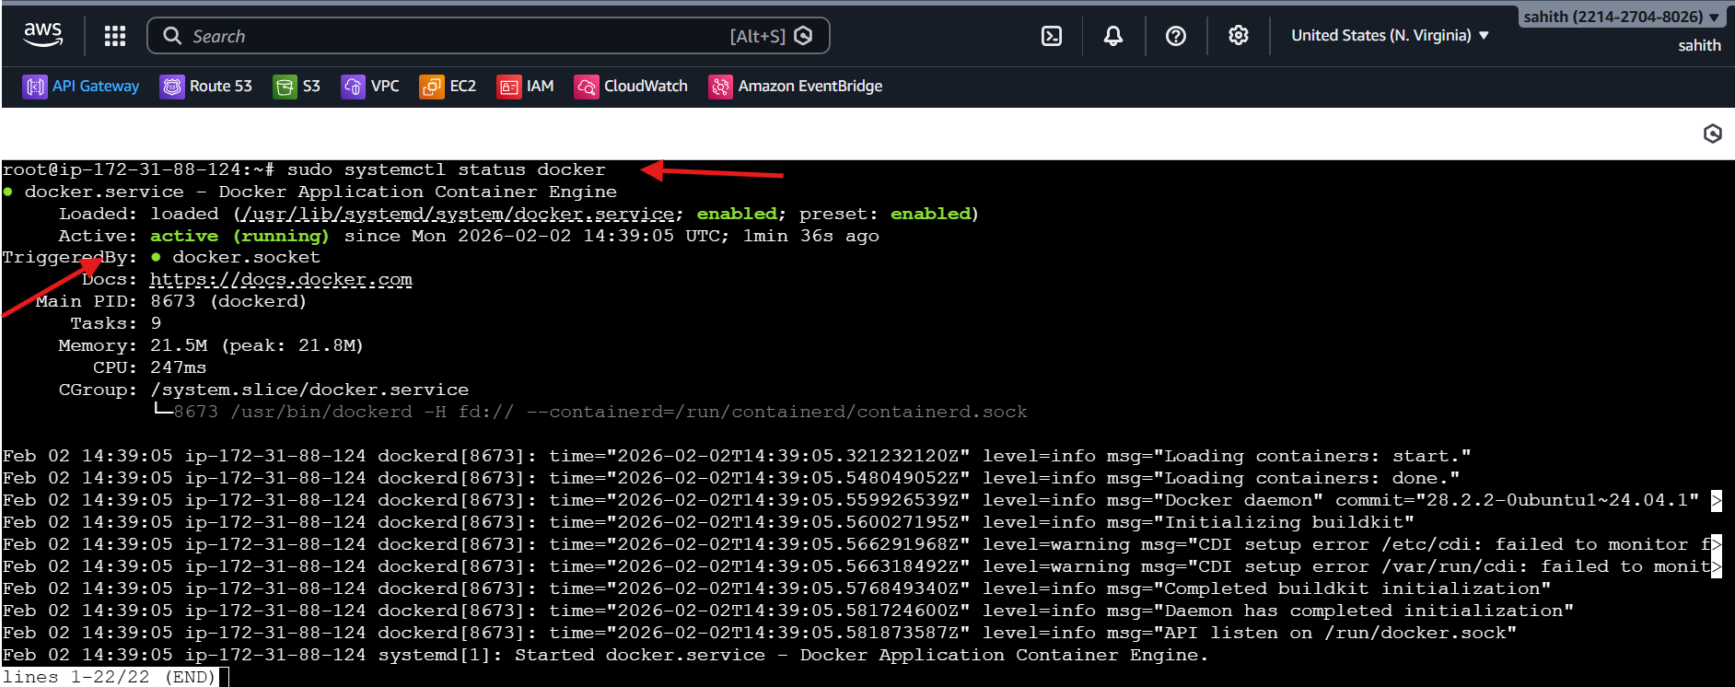
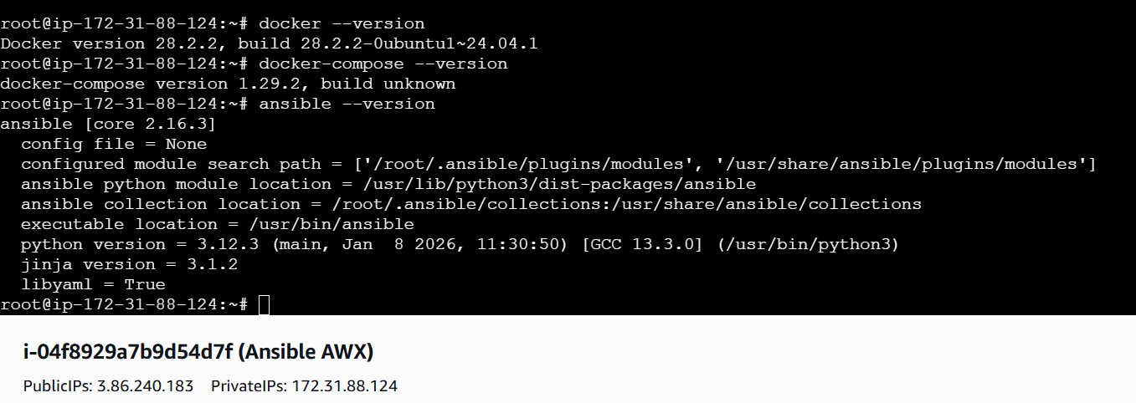
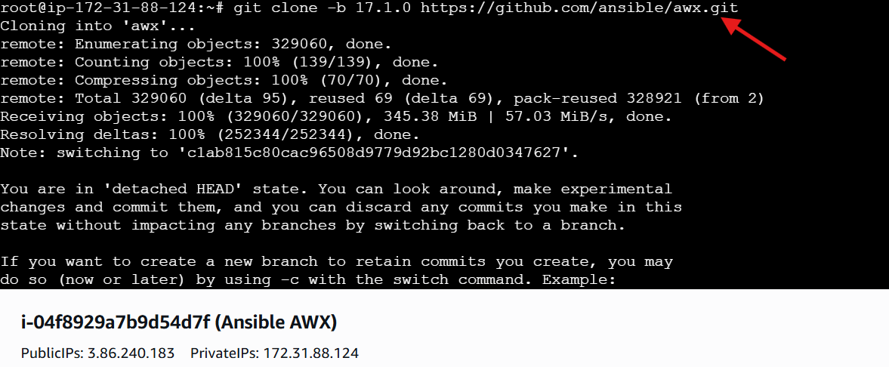
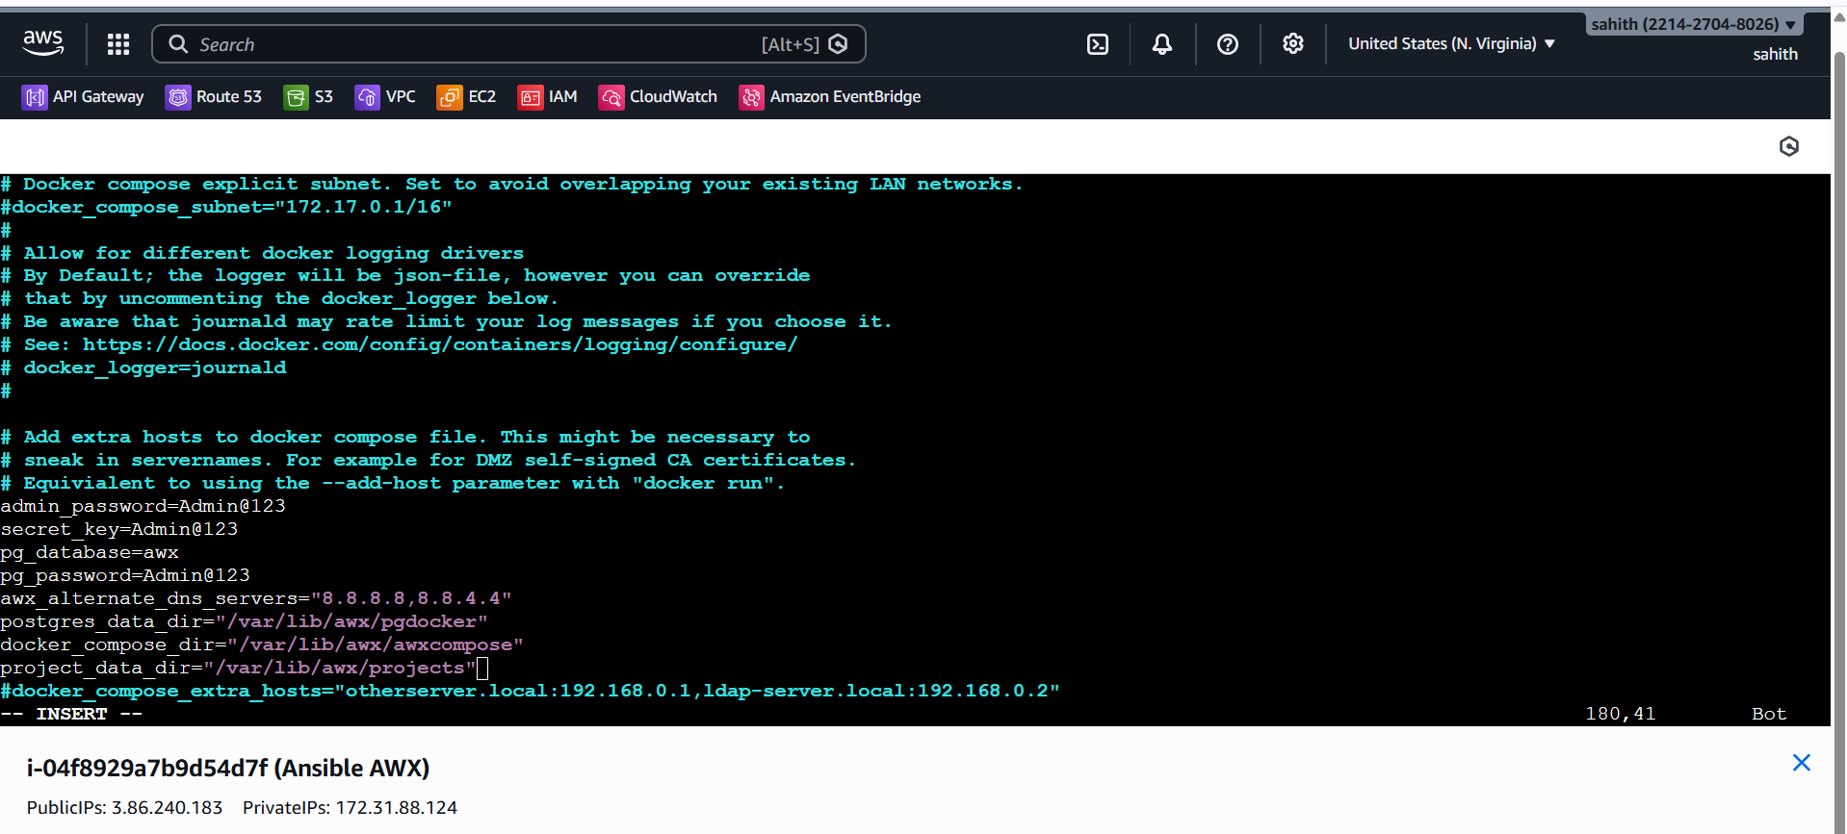
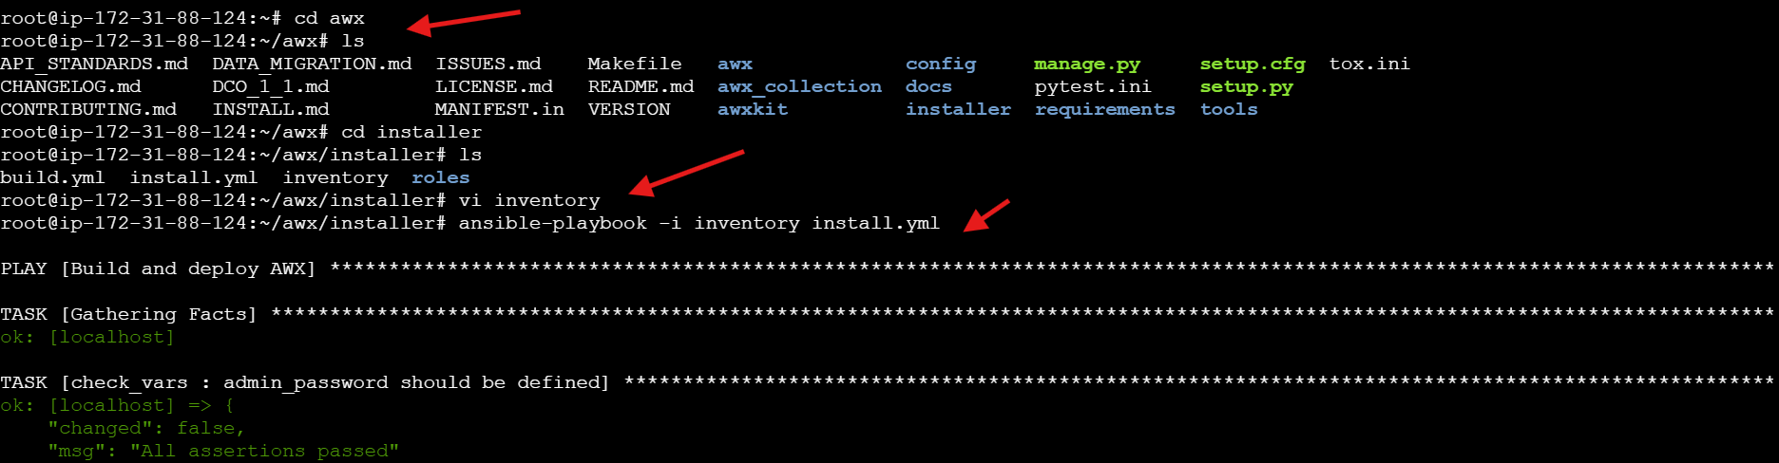
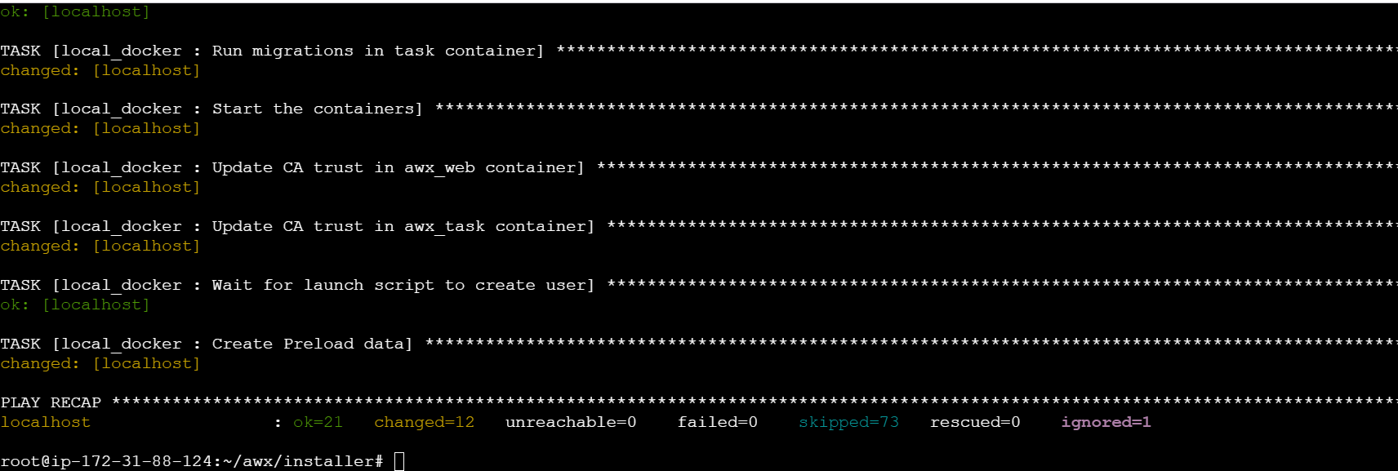
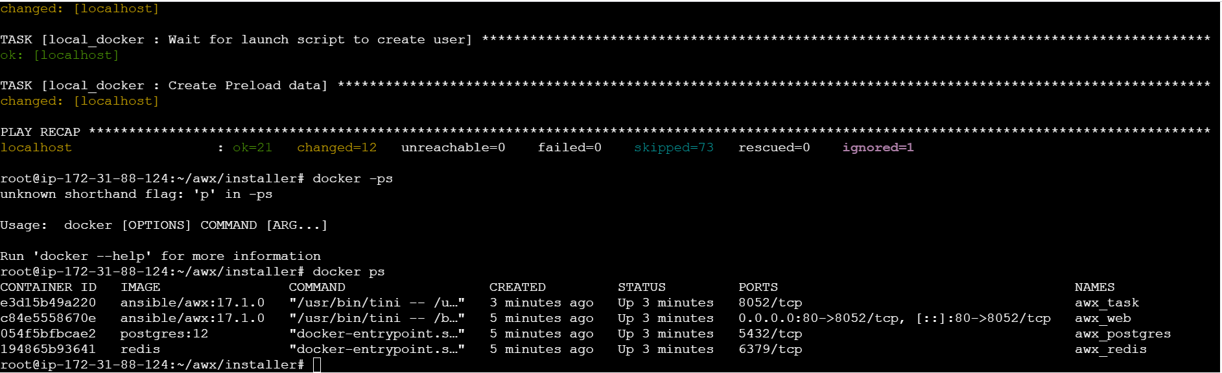
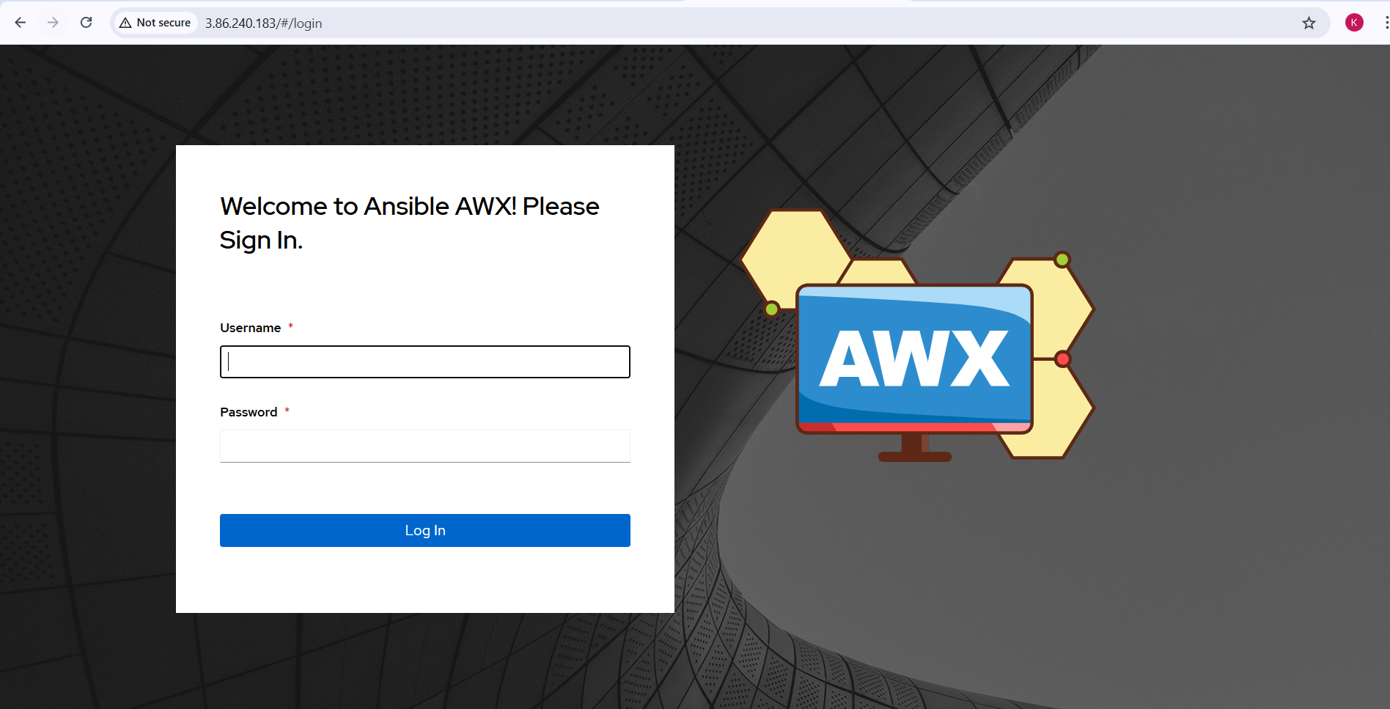
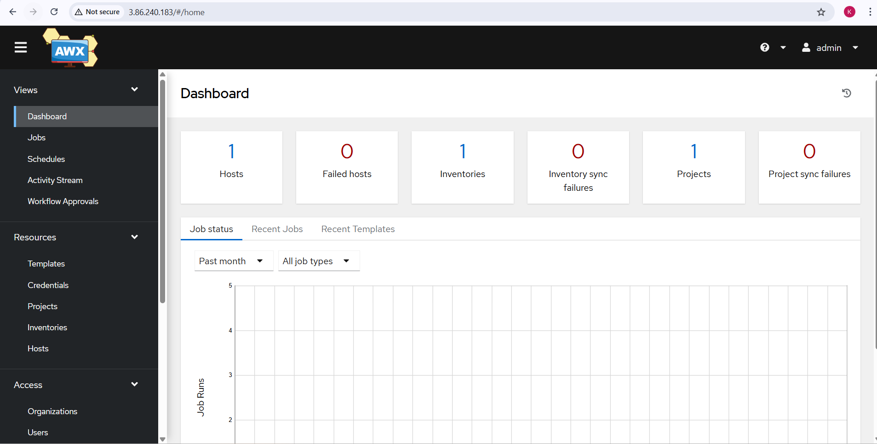
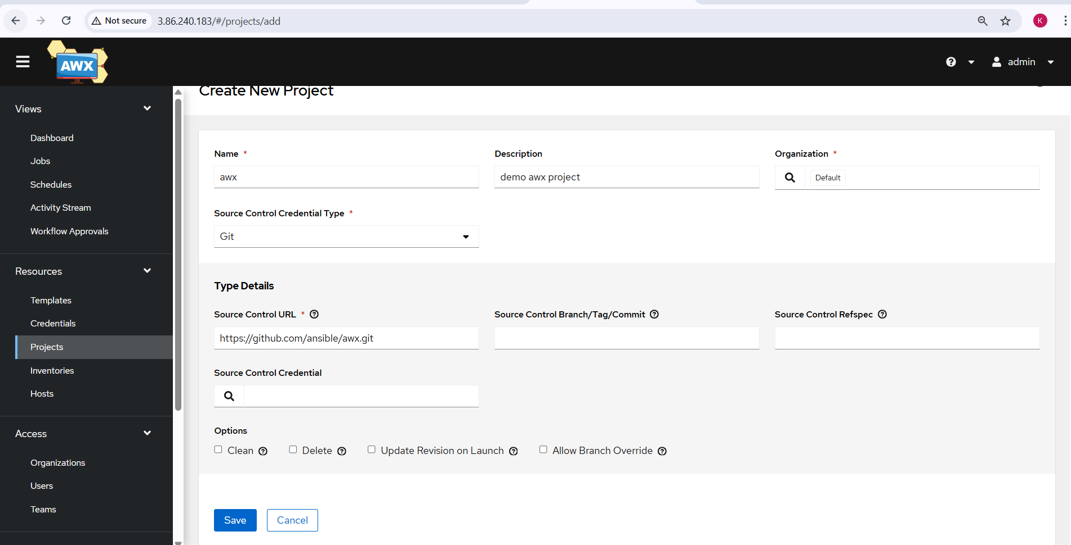
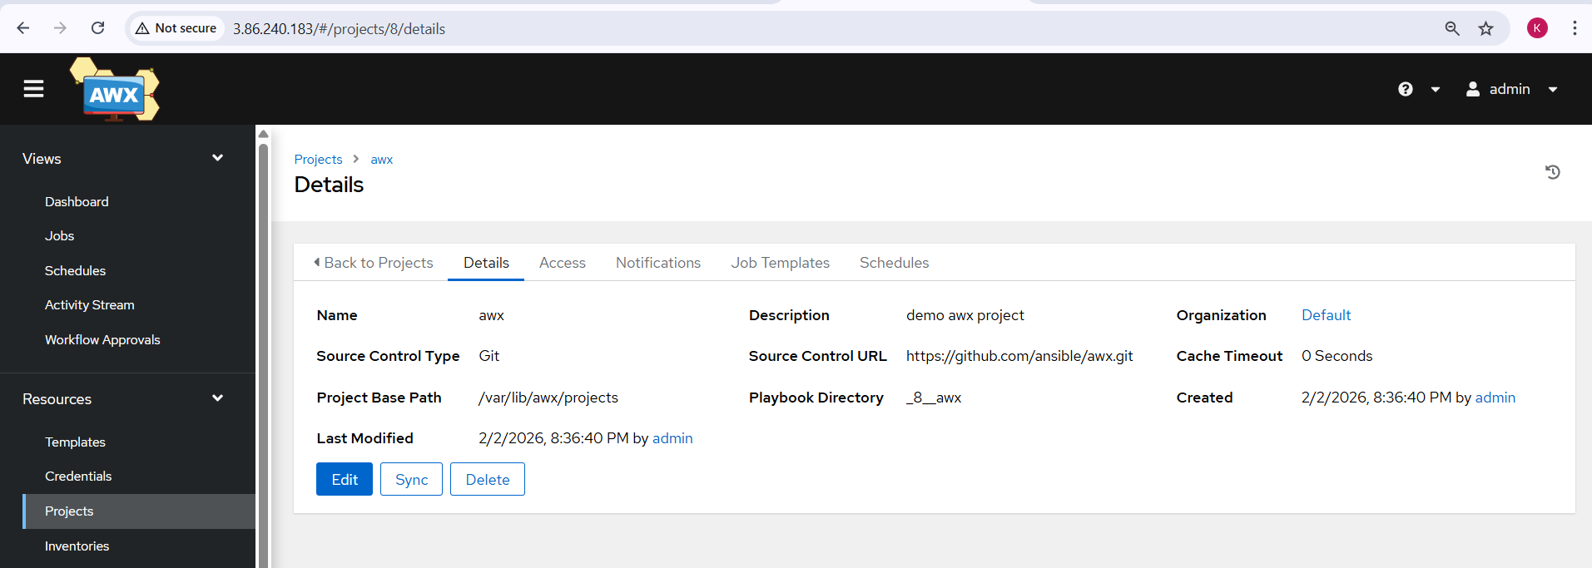
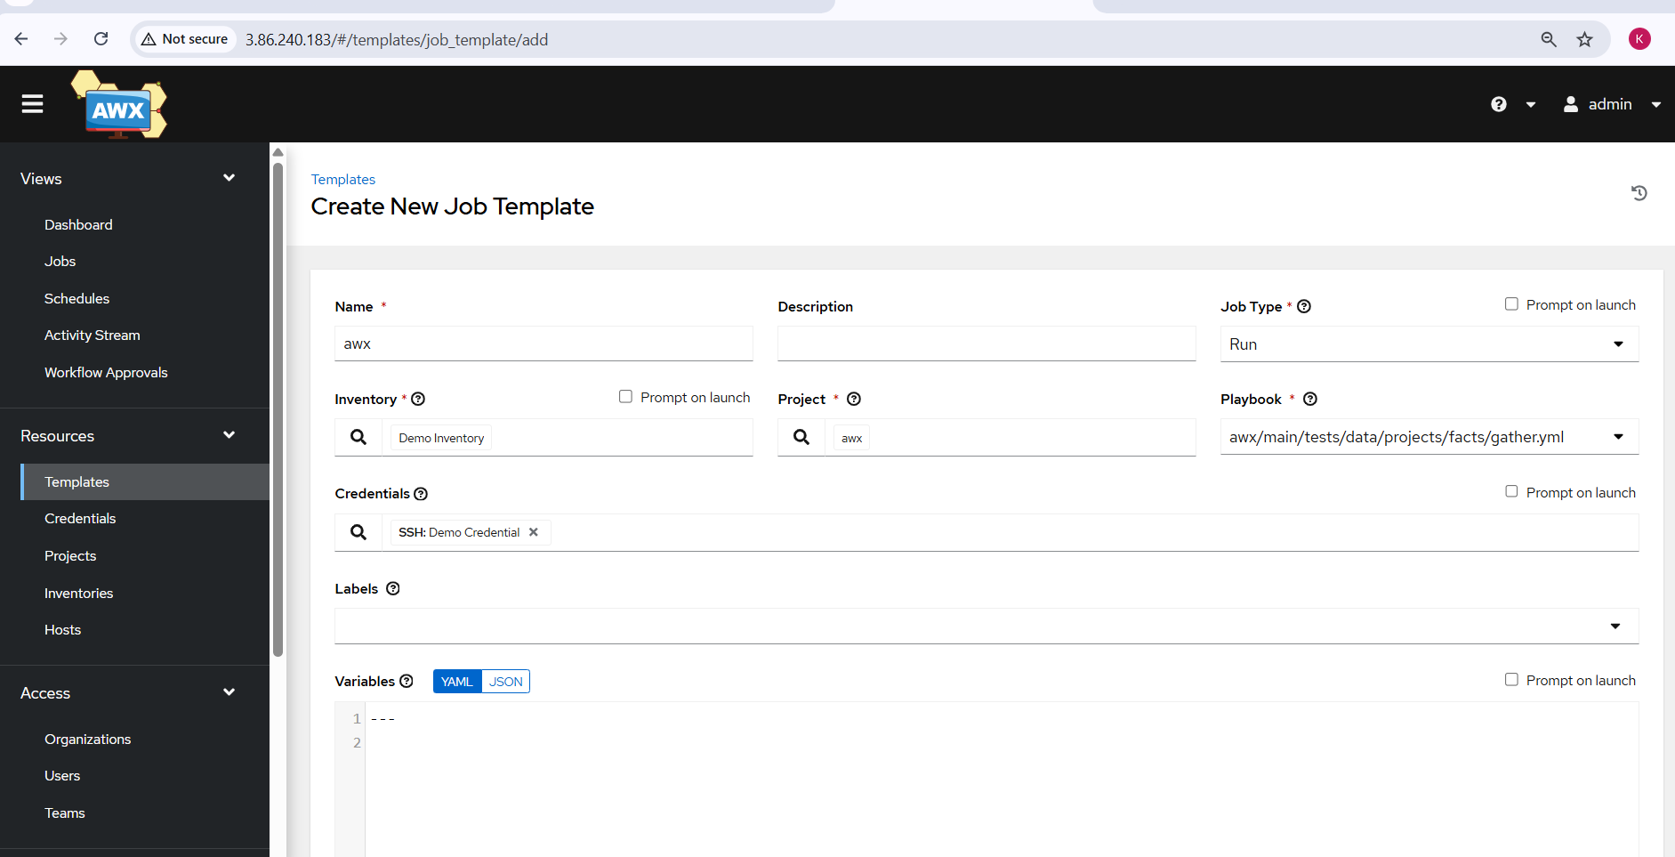
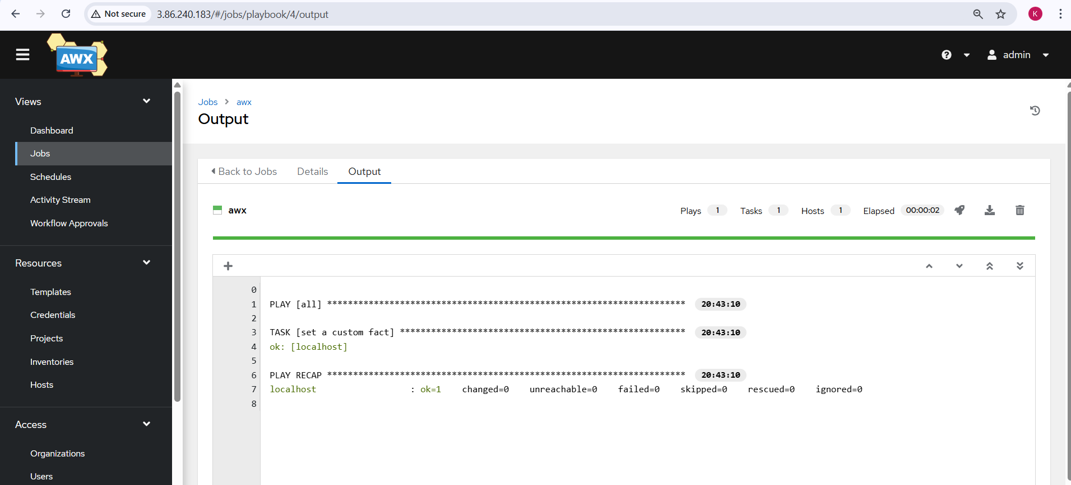

Issues Faced:
- Browser displayed “Not Secure” warning due to HTTP access
- Non-blocking inventory naming warnings
Conclusion:
Ansible AWX was successfully installed on Ubuntu using Docker and the Ansible installer. The AWX Web UI was accessed, a project and job template were configured, and an Ansible playbook was executed successfully, demonstrating complete end-to-end AWX automation functionality.

